1.0 PURPOSE

To define organizational context for NIHVA Technologies in accordance with QMS deployment

2.0 SCOPE

QMS established at NIHVA Technologies

DETAILS

  - Organization and its context

    - NIHVA determines external and internal issues that are relevant to its purpose and its strategic direction and that affect its ability to achieve the intended result(s) of its Quality Management System. These issues includes positive and negative factors / conditions and are identified in the form of strategic challenges and strategic advantages and reviewed / revised during strategic planning cycle.
    - External context is facilitated by considering issues arising from legal, technological, competitive, market, cultural, social and economic environments.
      - Political Factors- ecological/environmental issues; current and anticipated future legislation; international legislation and global influences; regulatory bodies, statutes and laws; governmental policies and regulations, funding, grants, and initiatives; market and political lobbying groups; wars and conflicts.
      - Economic Factors - national economic policies and trends; product and services taxation; market, trade and monetary conditions; sector specific conditions; interest and exchange rates; customers and end-users;
      - Social Factors – demographic and lifestyle trends; consumer buying patterns, attitudes and opinions; media views and reports; laws affecting social behavior; advertising and publicity; ethical and religious norms.
      - Technological Factors – competing technologies and advancements; maturity of products, services and processes; trends and advancements in information and communication technology; laws affecting licensing and patent and intellectual property protection; social media use
      - Marketing Factors – total market size and market penetration; barriers to entry; trends and indicators; state of maturity; knowledge of customers; competitors; channels of distribution; branding and packaging.
      - Environmental factors - weather and geography, Monsoon and rainfall
    - Internal context is facilitated by considering issues related with values, culture, knowledge and performance of the organization
      - Product and service offerings
      - Organizational structure, roles, and accountability
      - Applicable regulatory requirements
      - Assets (e.g. infrastructure - property, machinery, equipment and technology)
      - Capabilities in terms of resources and knowledge (e.g., capital, time, competent workforce, processes, management systems, and technologies)
      - Information and communication systems, information flows, and decision-making processes (both formal and informal).
      - Standards, guidelines, and models adopted by the organization and
    - Contextual issues influence an organization in various ways such as
      - Customer requirements and changes in requirements
      - Technological changes provide new and more effective ways to handle communications, operations, shipping and logistics
      - Government policies play a significant role in determining how businesses operate

      - Sociological forces often drive what, where and how consumers buy product and services. There is an increasing trend in the number of consumers purchasing products online and reading reviews before making a purchase

    - NIHVA ensures to establish, implement and maintain that the quality policy and objectives are compatible with the context and strategic direction of the organization. Risks and opportunities associated with its context and objectives are reviewed on annual basis.
    - A SWOT / PESTLE Analysis is carried out / reviewed annually and strategic / annual goals are determined to measure and monitor the performance.

Needs and expectations of interested parties

    - Key interested parties that are relevant to QMS are customers (external / internal) and suppliers
    - Key requirements and expectations from Customers are: quality, competitive pricing, on time delivery, after sales support
    - NIHVA’s requirements from its supplier base are capability, high quality, cost competitiveness and on- time delivery.
    - NIHVA has established processes to monitor and review information about these interested parties and their relevant requirements.

Interested party | needs and expectations
Customer | Quality, price & delivery
End-user | Product performance/ease of use/reliability/safety/ maintainability
Management | Business growth, sales & profitability/efficiency & effectiveness of operations
Employees | Good work environment/job security/health/safety/ training/ recognition
External providers of product  and services (suppliers; partners) | Increase scope and volume of purchases/long-term contractual arrangements/information on future requirements.
Regulatory Bodies | Compliance with applicable requirements
Government & Community | Environmental protection/Ethical behavior/growth in business and taxes to build infrastructure to support community services, activities  and institutions.

Scope of Quality Management System at NIHVA

NIHVA Technologies has determined the boundaries and the applicability of the QMS and how it relates to our Business Core Competency.

NIHVA Technologies is committed to applying all applicable requirements of the International Standard to the intent and Scope of our QMS.

The Scope of our QMS is available to internal and external parties and maintained as documented information. The QMS is determined, designed and implemented to cover and support the following Scope in Product range including business covering, developing and manufacturing, sourcing, assembly, testing & commissioning:

Product Range
    - Door Automation

    - Automation Solution
    - MHE- Material Handling Equipment’s

Industry Sectors
    - Automotive, Engineering
    - Pharmacy, Food, Chemical
    - Warehouses, Logistics Scope of QMS is

Design, manufacturing and/or assembly, supply, installation - commissioning, servicing of material handling equipment (Scissor lift, dock leveller) and door automation (Gates, sliding roof and rolling shutters)
    - Manufacturing and/or Assembly, Supply, installation - commissioning and servicing of all other Door Automation, Automation Solution products and SPMs

Quality management system and its processes

    - NIHVA Technologies has established, documented and implemented Quality Management System (QMS) in accordance with the requirements of ISO 9001:2015. The QMS is maintained and continually improved through the use of the quality policy, quality objectives, audit results, analysis of data, corrective and preventive action and management review. NIHVA Technologies utilizes Quality System Procedures (QSP) to provide employees and external providers (Suppliers), with detailed “How To” instructions and requirements. The documents support the achievement of quality compliance for each of the process steps. We retain Quality System Forms (QSF) which provide documented information substantiating the process inputs and outputs have been accomplished as planned.

    - Quality management system at NIHVA

      - Determines the inputs required and the outputs expected from the processes.
      - Determines the sequence and interaction of these processes
      - Determines and applies the criteria and methods (including monitoring, measurements and related performance indicators) needed to ensure the effective operation and control of these processes
      - Determines the resources needed for the processes and ensure their availability
      - Assigns the responsibilities and authorities for these processes
      - Addresses the risks and opportunities for these processes
      - Evaluates these processes and implements any changes needed to ensure that these processes achieve their intended results
      - Improves the processes and the quality management system
  - In case NIHVA chooses to outsource any process that affects product conformity with requirements, it is ensured that appropriate control is exercised over such processes as per the relevant quality procedures.

  - Process Interactions – Refer the chart below for brief overview of key process interactions at NIHVA. Refer ‘Key process alignment matrix’ for detailed overview

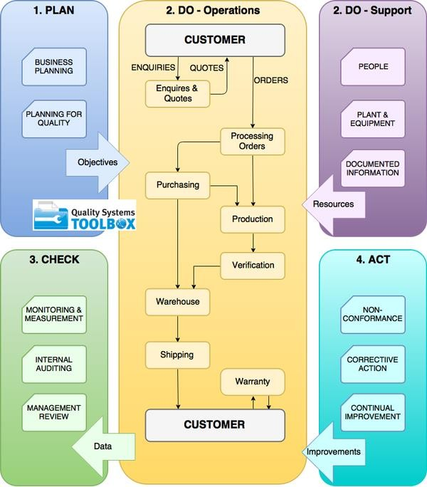

Support
- Human Resource & Competency
- Infrastructure
- Customers Requirement
- Organization and its Context
- Need and Expectation of relevant interested parties
- Environment
- Monitoring & Measuring Resources
- Documentation & Control
- Communication Resources
Operation
- Operational planning & Control
- Product & Service requirements (MKT)
- Externally provided process, product & service (Supplier)
- Production & Service
- Release of product & Service (Inspection)
- Non conforming product control

Planning
  - Risk & Opportunity
  - Quality Objective
  - Planning of Changes

Leadership
- Customer Focus
- Quality Policy
- Roles, Responsibilities &
Authorities

Performance Evaluation
- Customer satisfaction
- Customer Satisfaction
- Release of product & Service
- Data Analysis
- Internal audit
- MRM

Improvement
  - Nonconformity, Corrective action
  - Continual Improvement

